**Using ucanaccess driver to connect Java app to Ms Access.**

How to copy ucanaccess jar files into netbeans project.

1. Prepare your jar plugins folder. The folder should contains all required jar files (downloadable, refer to folder attached to get downloaded files)
2. In your netbeans project, go to the Libraries folder.

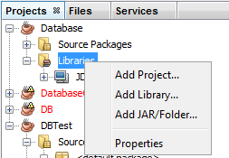

1. Choose Add JAR/Folder . Copy all files, and click Open

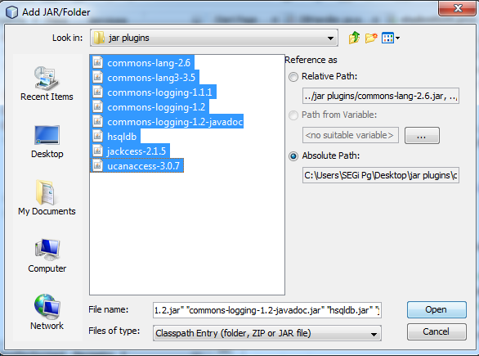

1. The files will be copied to the Libraries folder, as shown below.

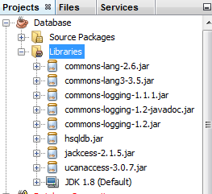

1. Finish.